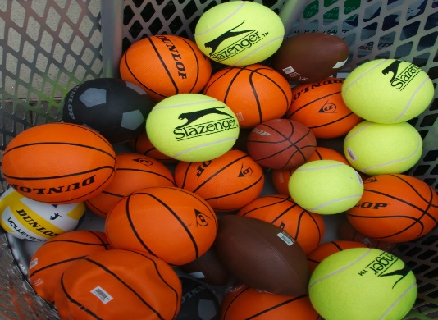
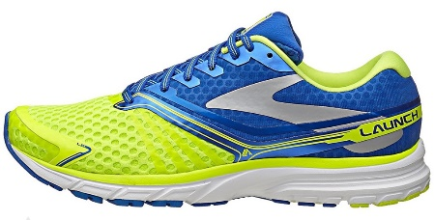
Guess who is being active for Active Schools’ Week….

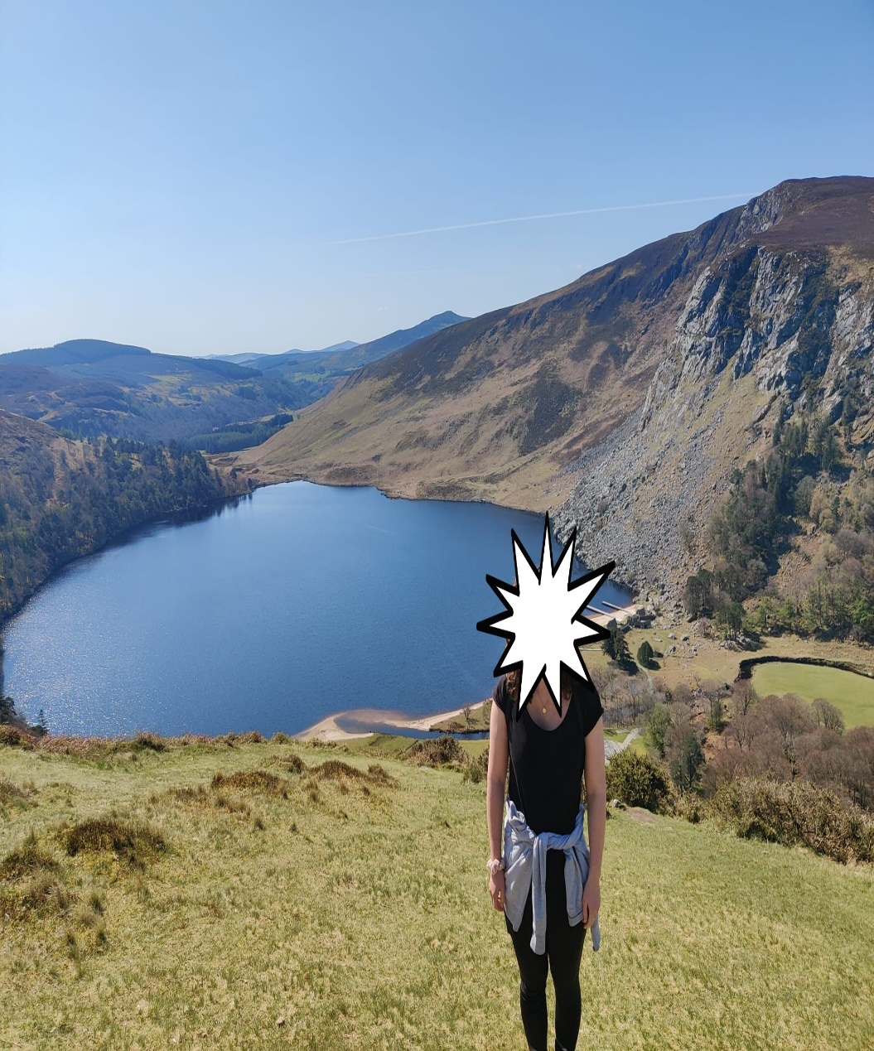
- Is it….
- Ms. Cafferkey
- Ms. Walsh
- Ms. Tuohy
- Ms. Fitzpatrick

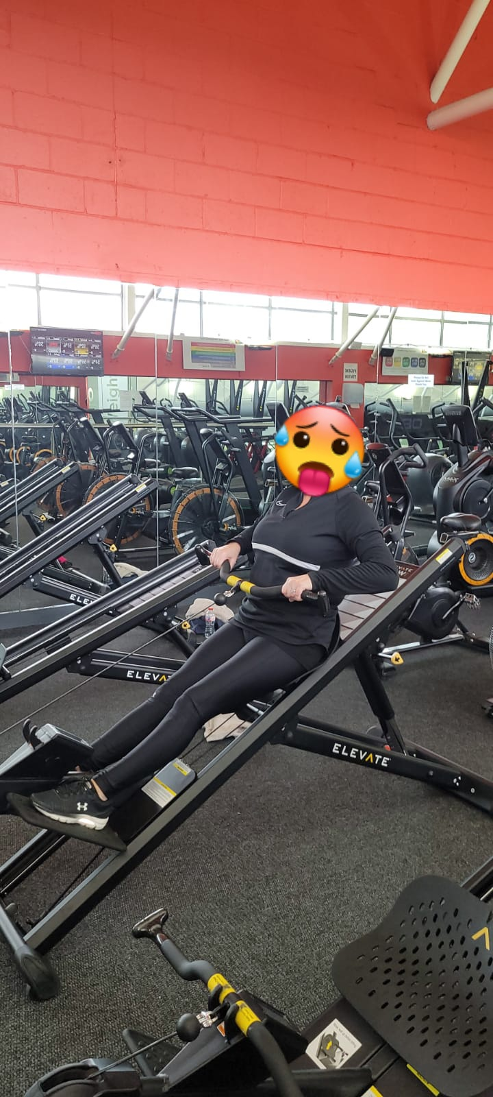
- Is it….
- Ms. Boland
- Vicky
- Marie
- Ms. Kirrane

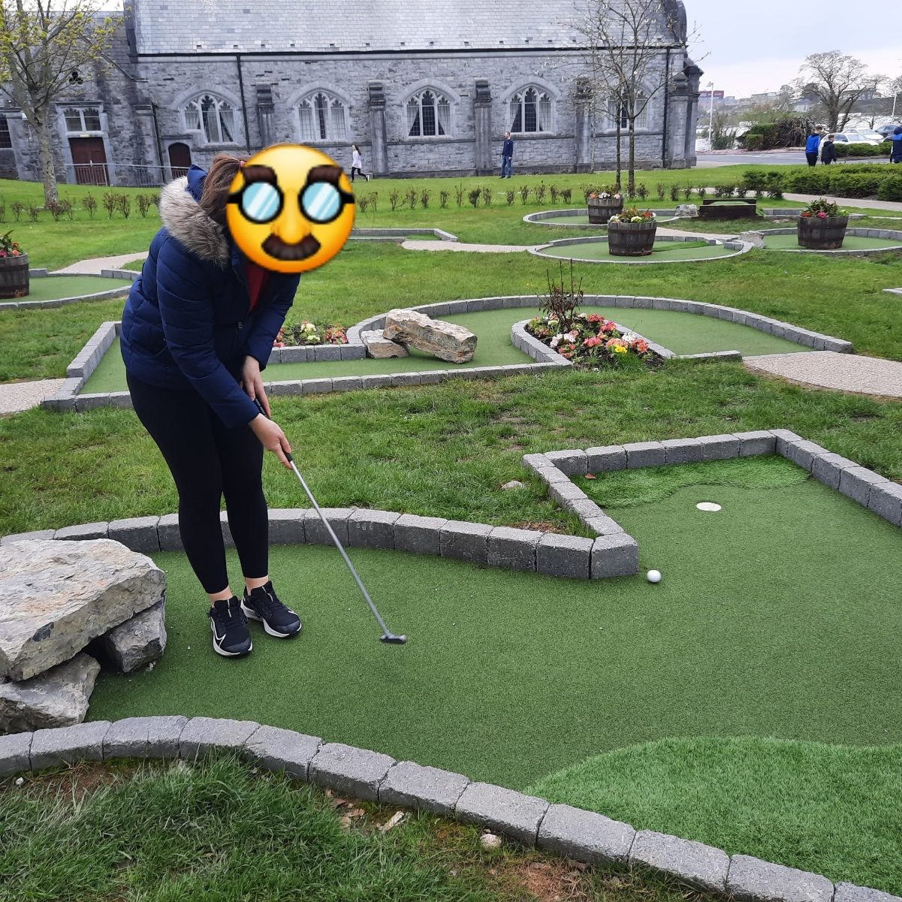
- Is it….
- Ms. Maguire
- Ms. O’Meara
- Ms. Mc Callig
- Ms. Kenny

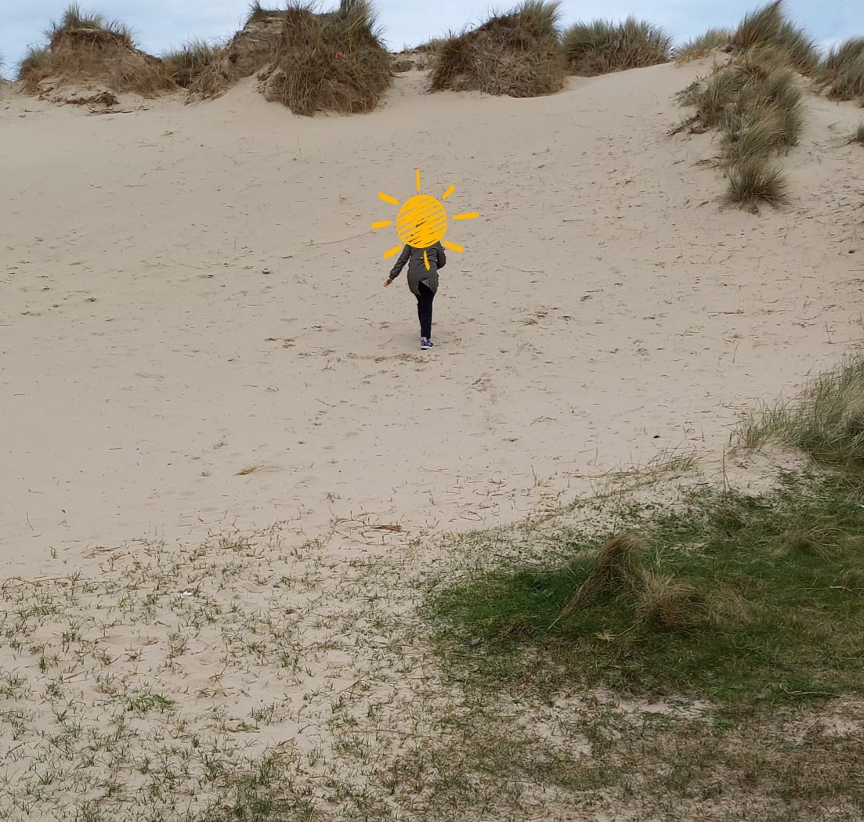
- Is it….
- Ms. Ryan
- Ms. Giblin
- Ms. O’Connor
- Sharon

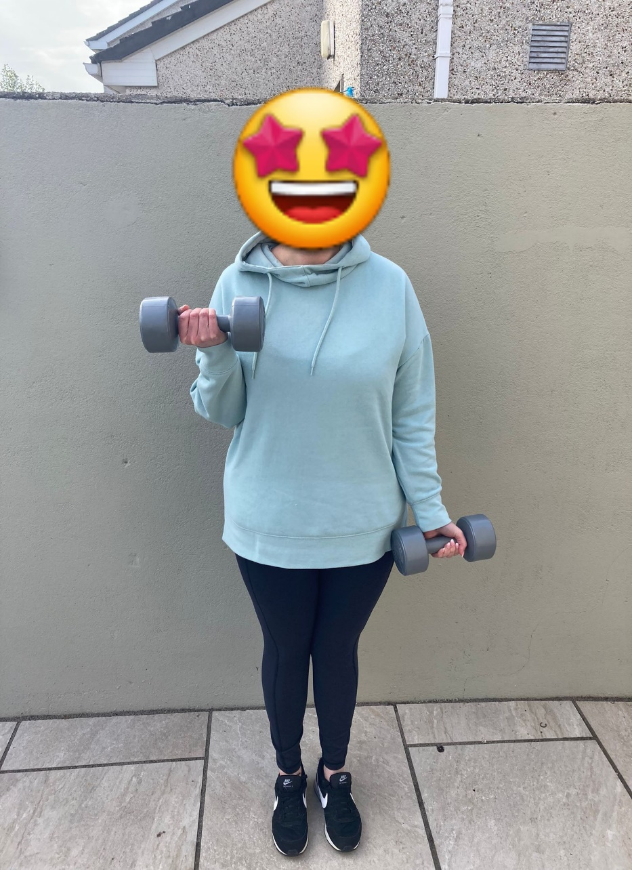
- Is it….
- Ms. Mc Dermott
- Teresa
- Ms. Burke
- Ms. Duff

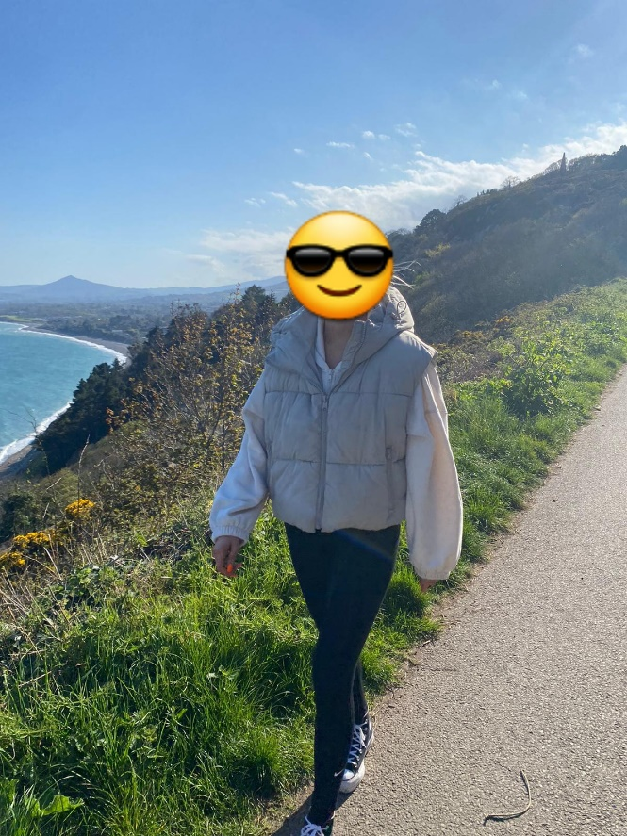
- Is it….
- Ms. Mc Mahon
- Ms. Hudson
- Ms. Troy
- Ms. Fox

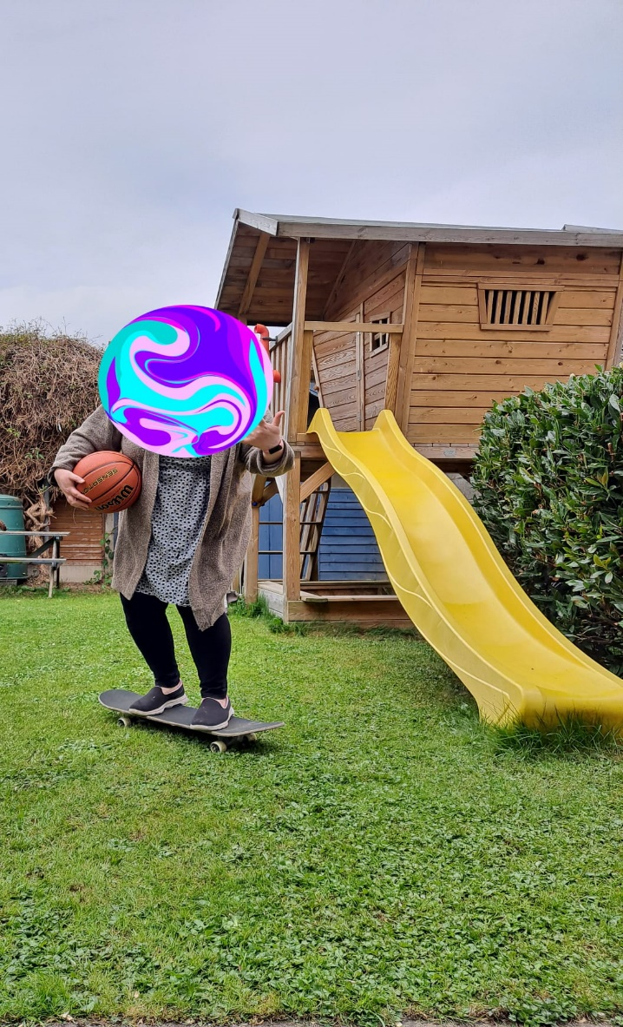
- Is it….
- Ms. Leahy
- Ms. Ruane
- Mary
- Ms. Healy

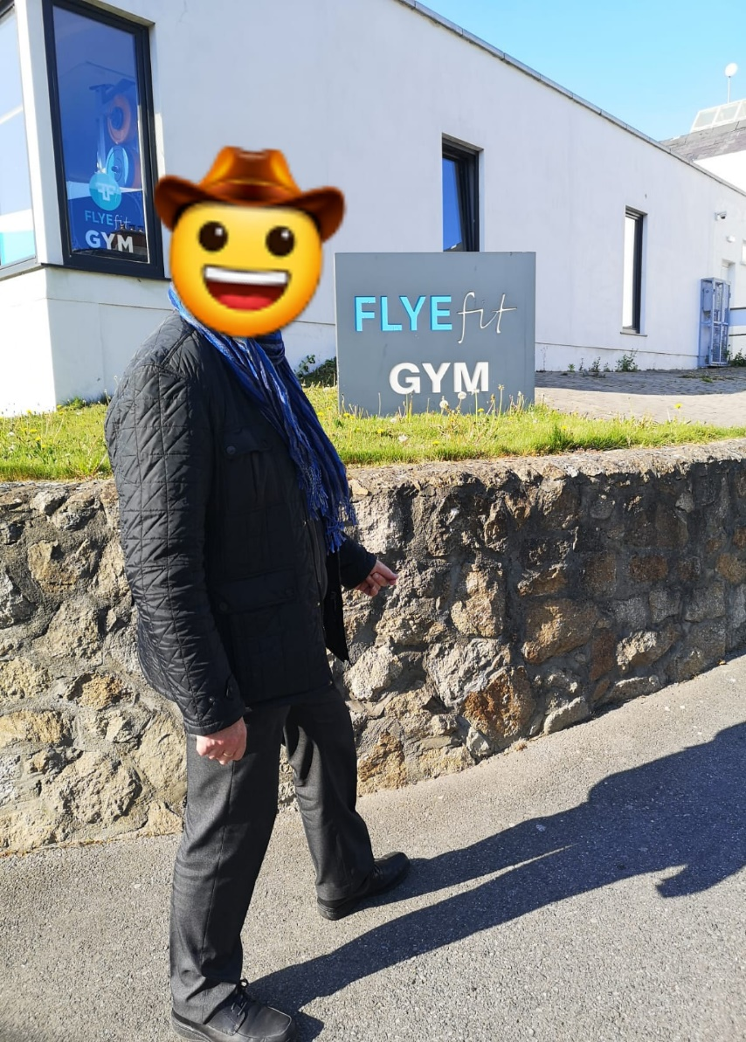
- Is it….
- Mr. Morris
- Jay
- Dessie
- Donald Trump

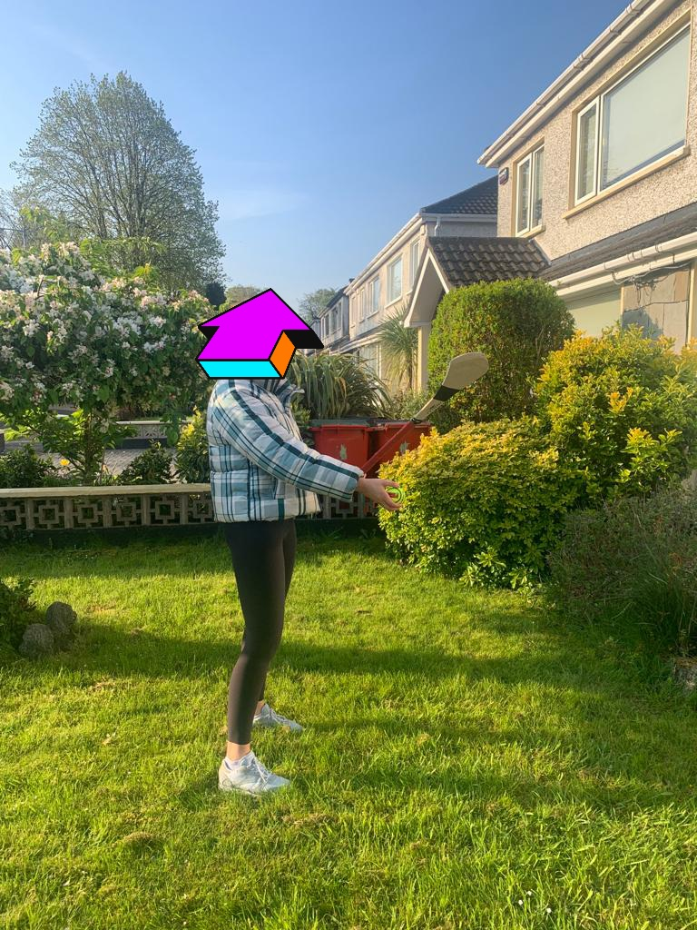
- Is it….
- Leona
- Ms. Heavey
- Ms. Boland
- Ms. O’Leary

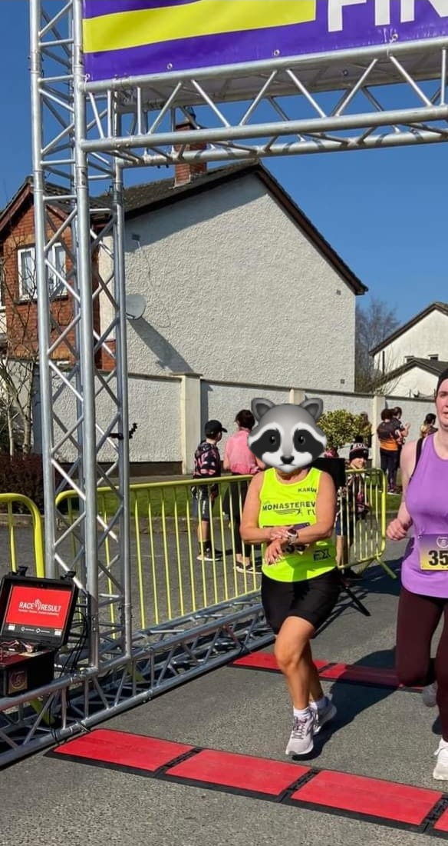
10.Is it….
- Karen
- Ms. Cummins
- Audrey
- Ms. Feighery

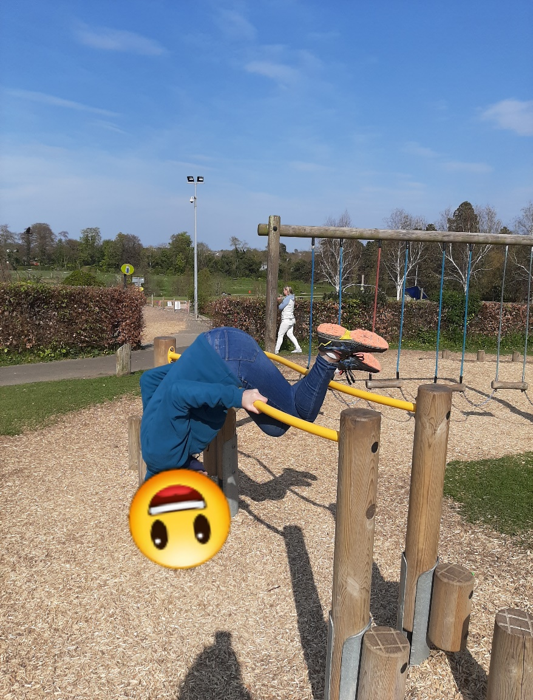
11.Is it….
- Ms. O’Brien
- Ms. O’Meara
- Ms. O’Connor
- Ms. Olé Olé Olé Olé

12. Is it….
- Ms. Hudson
- Amanda
- Ms. Kenny
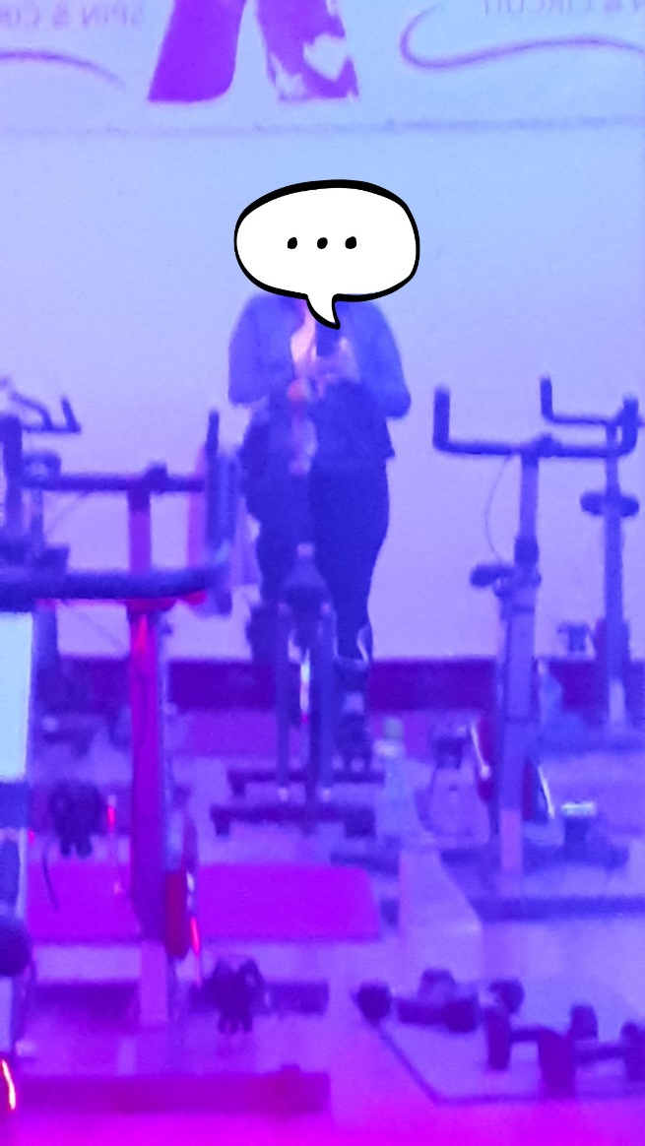
- Ms. Ryan

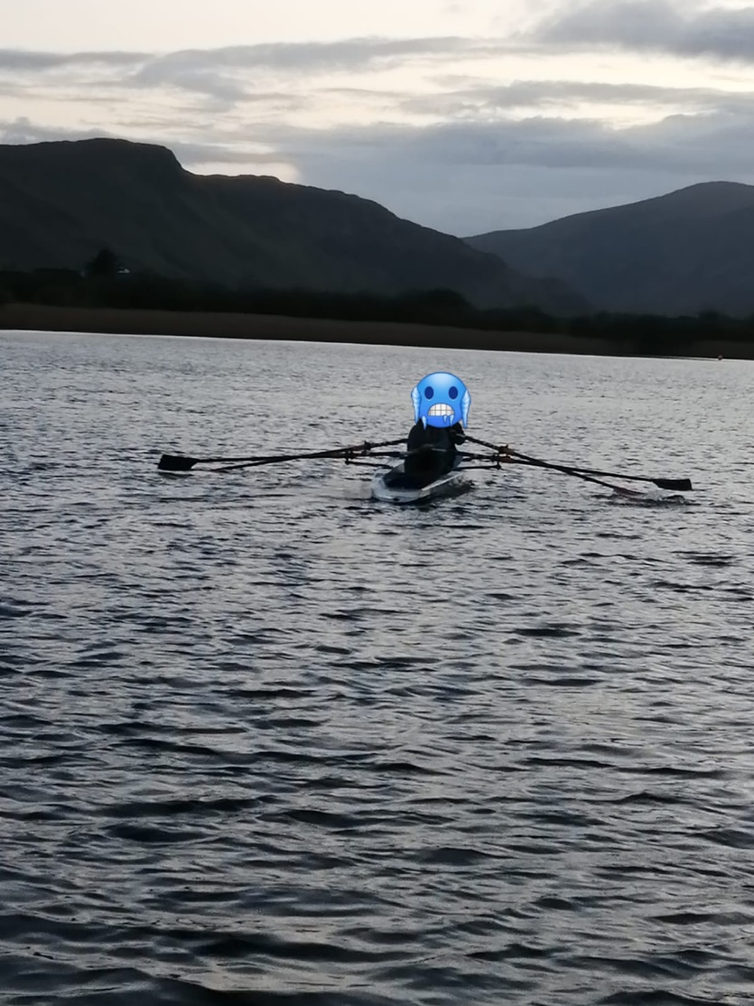
13. Is it….
- Mr. Morris
- Ms. Maguire
- Ms. Fox
- Ms. Mc Nelis

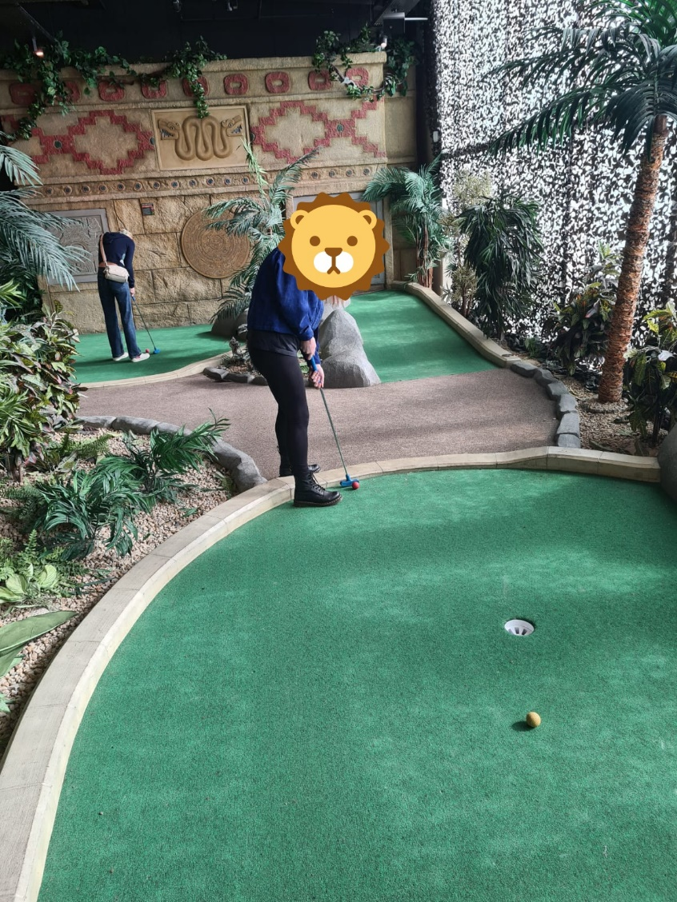
14. Is it….
- Ms. Heavey
- Vicky
- Ms. Fitzpatrick
- Ms. O’Leary

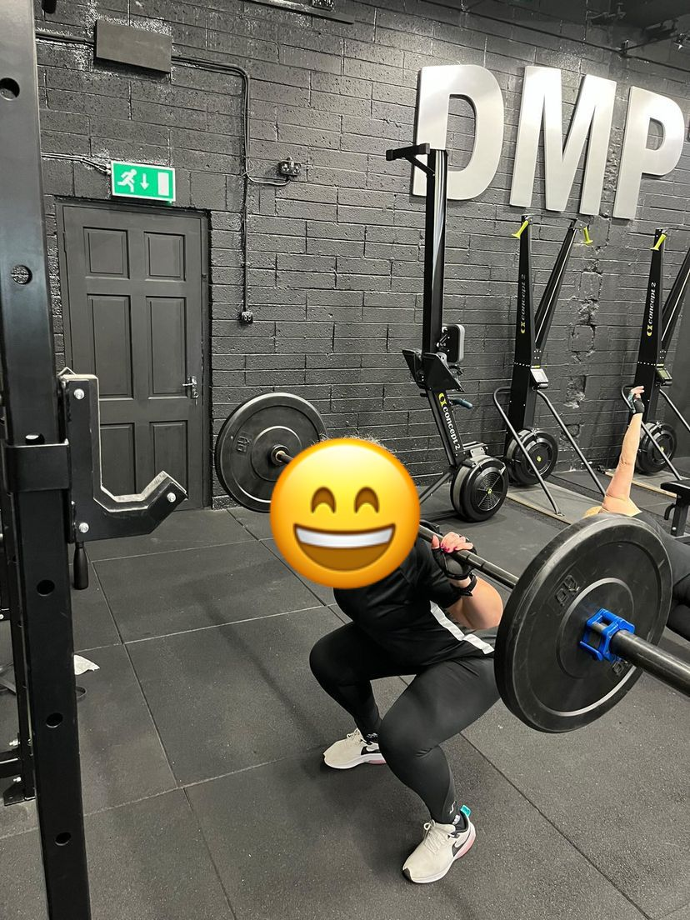
15. Is it….
- Ms. Kirrane
- Ms. Troy
- Jess
- Ms. Cummins

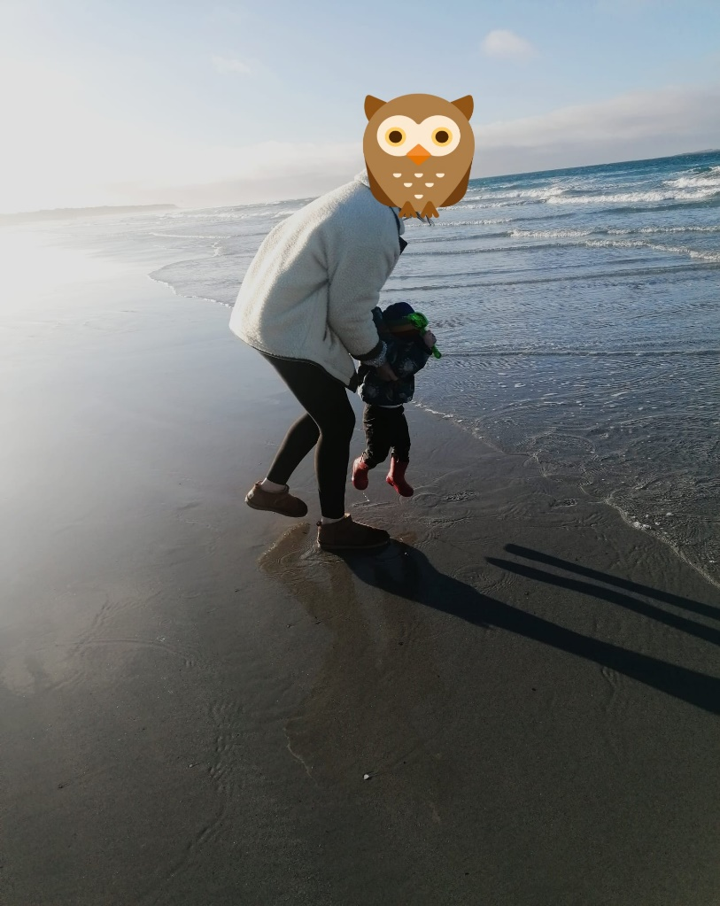
16. Is it….
- Ms. Reilly
- Ms. Heavey
- Ms. Ruane
- Ms. O’Connor

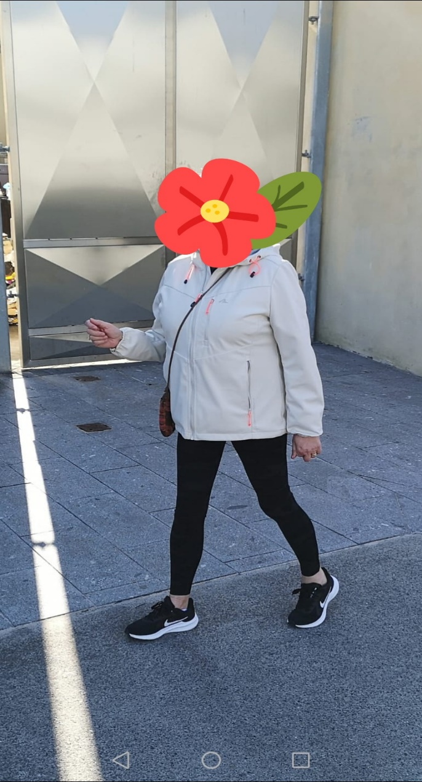
17. Is it….
- Ms. Duff
- Ms. Tuohy
- Ms. Mc Calig
- Ms. Giblin

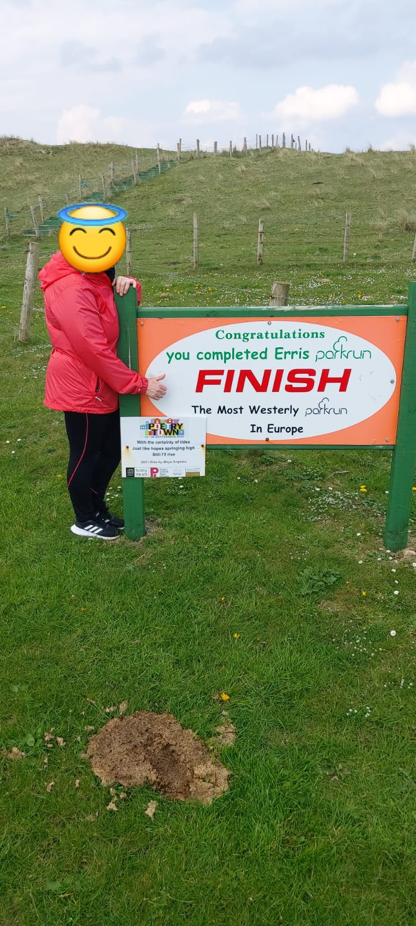
18. Is it….
- Audrey
- Ms. Hudson
- Sharon
- Ms. Healy

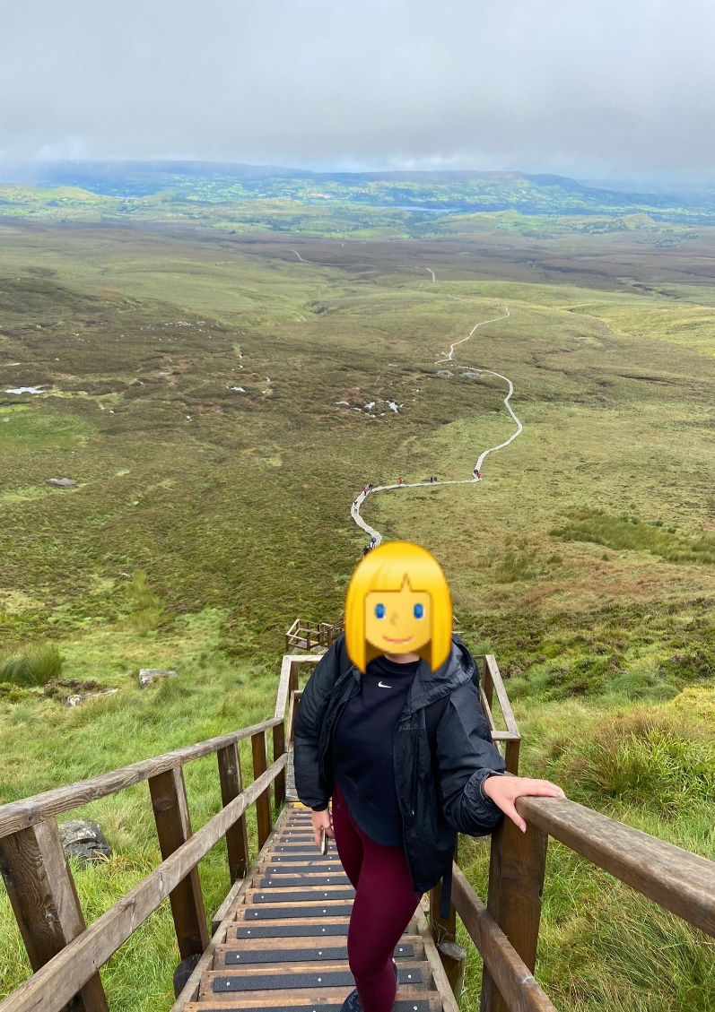
19. Is it….
- Ms. Mc Dermott
- Ms. Mc Mahon
- Ms. Mc Nelis
- Knick, Knack, Paddy, Whack

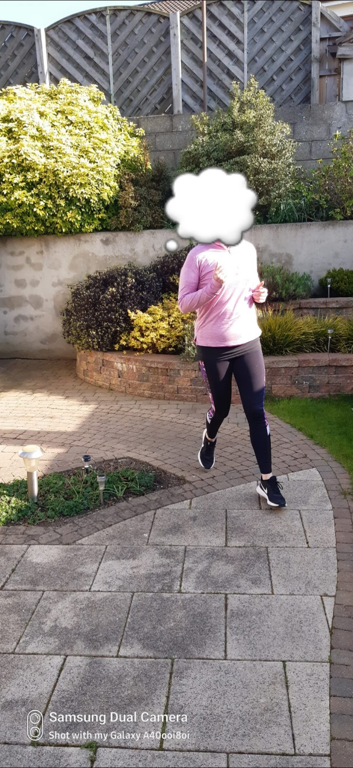
20. Is it….
- Sonic the Hedgehog
- Ms. O’Leary
- Ms. Ryan
- Ms. Boland

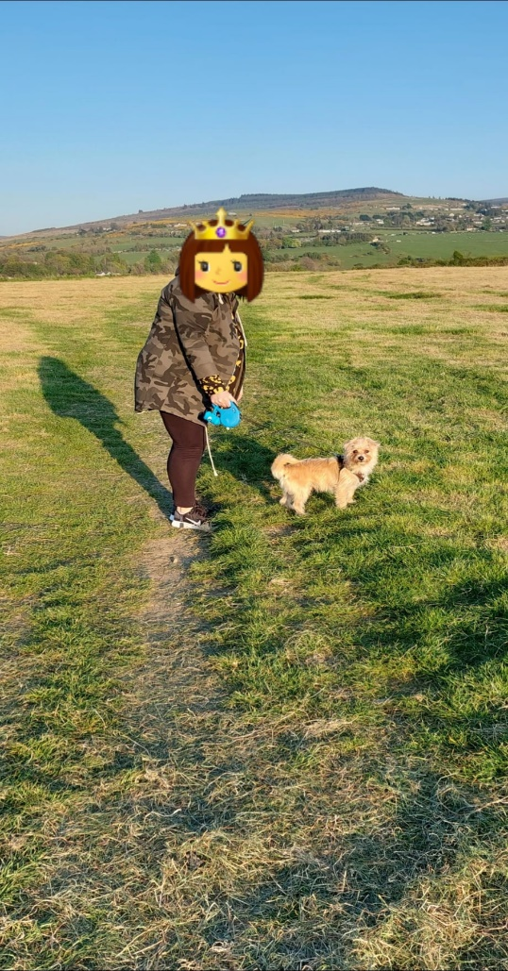
21. Is it….
- Ms. Burke
- Ms. Sharkey
- Sharon
- Vicky

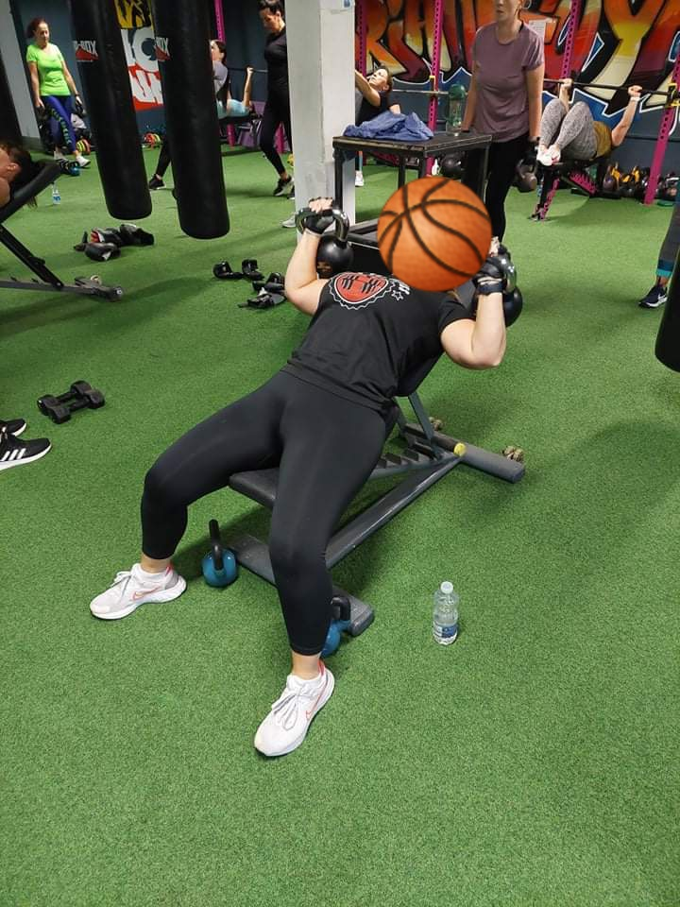
22. Is it….
- Wonder Woman
- Jess
- Marie
- Ms. Kirrane

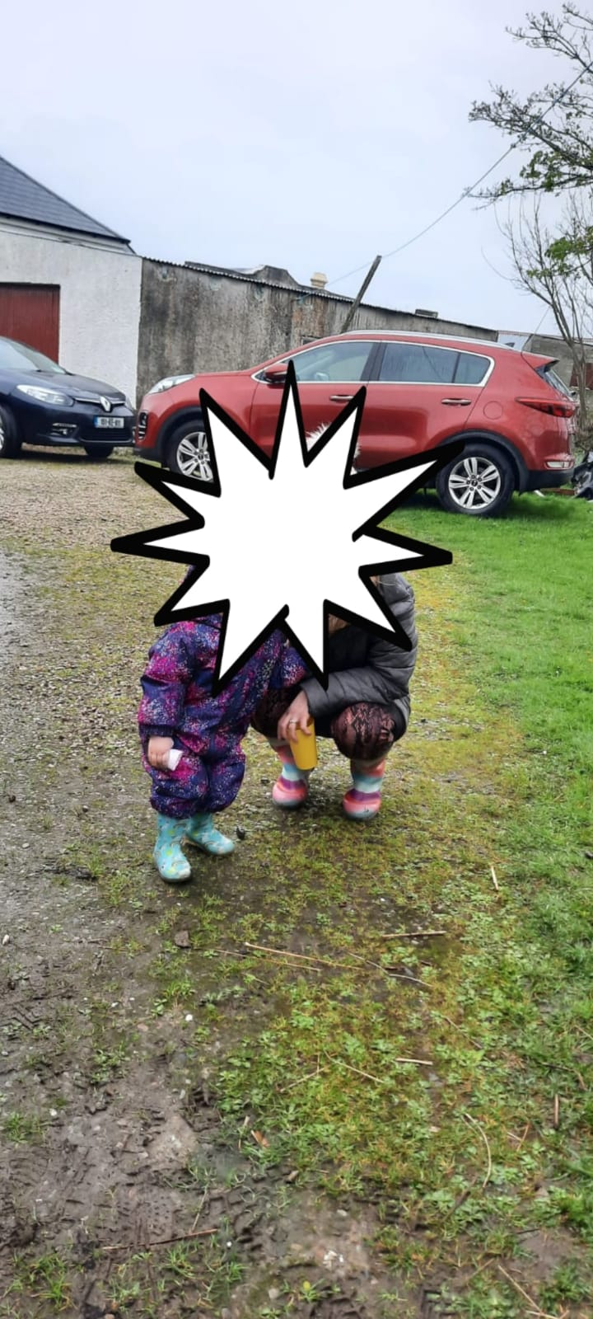
23. Is it….
- Ms. Reilly
- Ms. Burke
- Ms. Mc Dermott
- Ms. Heavey

Well done for completing the Active Schools’ Guess Who quiz.
Good Luck!

